SUBMITTED BY:

NAME: | M. KARTHIK REDDY
ROLL NO: | CSE25037
YEAR / SEM / SECTION | 2 / 3 / CSE-A
CREDITS | 5

SUBMITTED TO:

NAME: | Dr. RAJKUMAR BATCU
DEPARTMENT | SCHOOL OF COMPUTING
DESIGNATION | ASST. PROFFESOR (SI grade)

S NO: | TITLE | PAGE | REMARKS
1 | WEEK 1:  1a: Recursive countdown from n  1b: Recursive calculation of compound growth factor  1c: Recursive search for emo id in list  1d: Recursive factorial calculation  1e: Recursive fibonacci series
2 | WEEK 2:  2a: Perform linear search  2b: Perform binary search

LAB 1

1. AIM:

A rocket launch system displays a countdown. Use no loops. Write a Python program to display the countdown from n to 1, followed by “Launch”.

PROGRAM:

def countdown(n):
print(n)
if n==0:
return 0
else:
return countdown(n-1)

n=int(input("enter number"))
print(countdown(n))

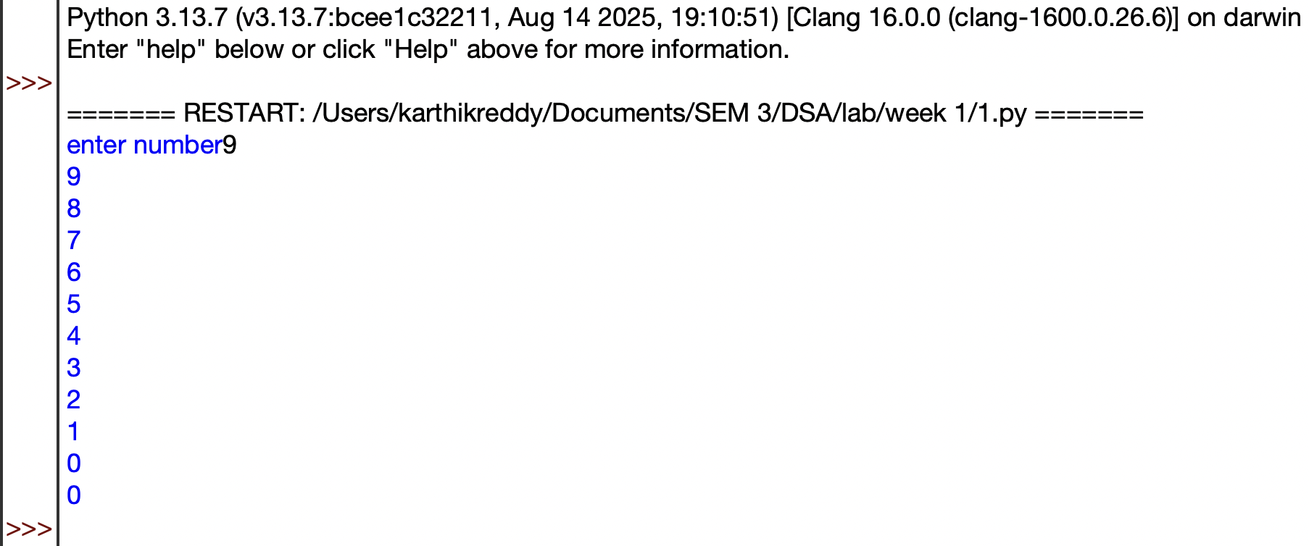

OUTPUT:

EXPLANATION:

- Defines a recursive countdown() function that prints numbers in decreasing order.
- Prints the current value of n before making the recursive call.
- When n becomes 0, the recursion stops.
- Otherwise, the function calls itself with n-1.
- Takes the starting number as input and displays the countdown.

ERROR TABLE:
S.No. | Error Obtained | Rectification
1 | Countdown does not stop | Check the condition when n reaches 0
2 | Program stops for a very large number | Use a loop instead of recursion
3 | Negative numbers are printed unexpectedly | Allow only non negative starting values

2. AIM:

Banks calculate the growth of an investment using compound interest. The formula requires calculating powers, which can be implemented recursively. Write a recursive program to calculate pⁿ (power), where p = principal growth factor and n = number of years.

PROGRAM:

def power(p,n):
if n<=0:
return 1
else:
return p*power(p,n-1)

p=int(input("Enter prinipal"))
n=int(input("Enter number"))
Print(power(p,n))

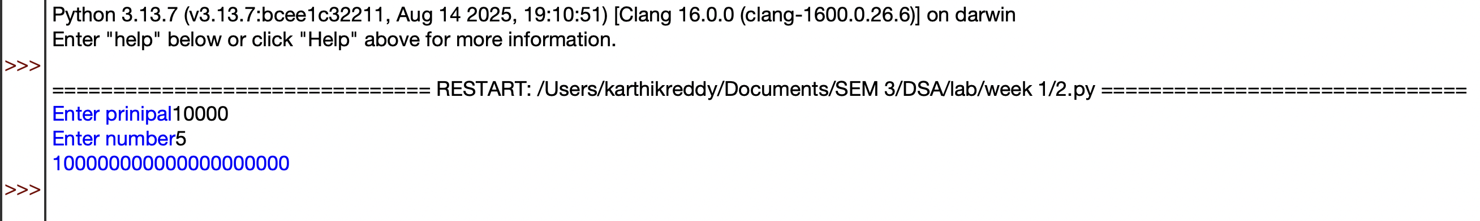
OUTPUT:

EXPLANATION:

- Defines a recursive power() function to calculate \(p^n\).
- Returns 1 when n <= 0, which is the base case.
- Otherwise, multiplies p by power(p, n-1) repeatedly.
- Takes the base (p) and exponent (n) as input.
- Calls the function and prints the calculated power.

ERROR TABLE:
S.No. | Error Obtained | Rectification
1 | Incorrect result for negative exponent | Add separate handling for negative exponents
2 | Program becomes slow for large exponent | Use an efficient power calculation method
3 | Wrong result for exponent zero | Make sure the base case returns 1

3. AIM:

An HR department stores employee IDs in a list. Develop a recursive program to search for a given employee ID. Write a recursive function to search for an employee ID in a list.

PROGRAM:

def search(A,k,n=0):
if n>=len(A):
return -1
if A[n]==k:
return n
return search(A,k,n+1)

A=[1,2,3,4,5,6,7,8]
print(A)
k=int(input("enter id to search"))

Print(search(A,k))

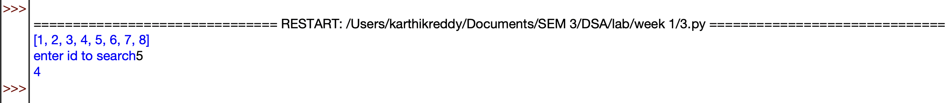
OUTPUT:

EXPLANATION:

- Defines a recursive search() function to find the target element in the list.
- Checks each element starting from index 0 using recursion.
- If the target is found, its index is returned.
- If the end of the list is reached, -1 is returned.
- Takes the target value as input and displays the search result.

ERROR TABLE:
S.No. | Error Obtained | Rectification
1 | Target element is not found | Check whether the target exists in the list
2 | Recursion stops before checking all elements | Verify the index increment in the recursive call
3 | Program stops for a large list | Use an iterative search method

4. AIM:

In a logistics company, the number of possible ways to arrange n different parcels is calculated using the factorial formula (n!). Develop a recursive program to calculate the factorial of a given number.

PROGRAM:

def factorial(n):
if n<=0:
return 1
else:
return n*factorial(n-1)

n=int(input("Enter number"))
print(factorial(n))

OUTPUT:

EXPLANATION:

- Defines a recursive factorial() function to calculate the factorial of a number.
- Returns 1 when n <= 0, which also handles 0!.
- Otherwise, multiplies n by factorial(n-1) until reaching the base case.
- Takes a number as input from the user.
- Calls the function and prints the factorial result.

ERROR TABLE:
S.No. | Error Obtained | Rectification
1 | Incorrect factorial for negative input | Restrict the input to non negative numbers
2 | Program stops for a large number | Use an iterative approach
3 | Wrong factorial result | Check the recursive multiplication and base condition

5. AIM:

Write a recursive Python program to print the first n terms of the Fibonacci series.

PROGRAM:

def fibonacci(n):
if n<=0:
return 0
elif n==1:
return 1
else:
return fibonacci(n-1)+fibonacci(n-2)

n= int(input("Enter terms"))
for i in range(n):
print(fibonacci(i))

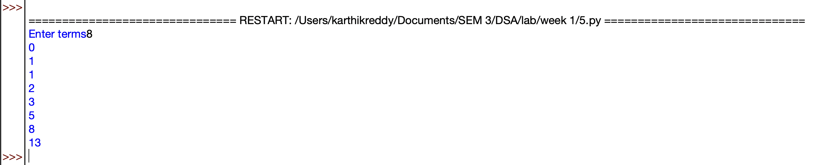
OUTPUT:

EXPLANATION:

- Defines a recursive fibonacci() function to calculate Fibonacci numbers.
- Returns 0 for n <= 0 and 1 for n == 1.
- For other values, it recursively adds the previous two Fibonacci numbers.
- Takes the number of terms from the user.
- Uses a loop to generate and print each Fibonacci term.
- The sequence starts as 0, 1, 1, 2, 3, 5, ....

ERROR TABLE:
S.No. | Error Obtained | Rectification
1 | Program runs very slowly | Use an iterative or optimized approach
2 | Incorrect sequence is displayed | Check the base conditions for 0 and 1
3 | Program stops for large input | Avoid excessive recursive calls

LAB 2

1. AIM:

Write a program to perform linear search on a given input.

PROGRAM:

def linearSearch(a,key):
for i in range(n):
if a[i]==key:
return i
return -1

n=int(input("Enter number of elements"))
a=[]
for i in range(n):
x=int(input("enter elements"))
a.append(x)
key=int(input("Enter target element"))
Print(linearSearch(a,key))

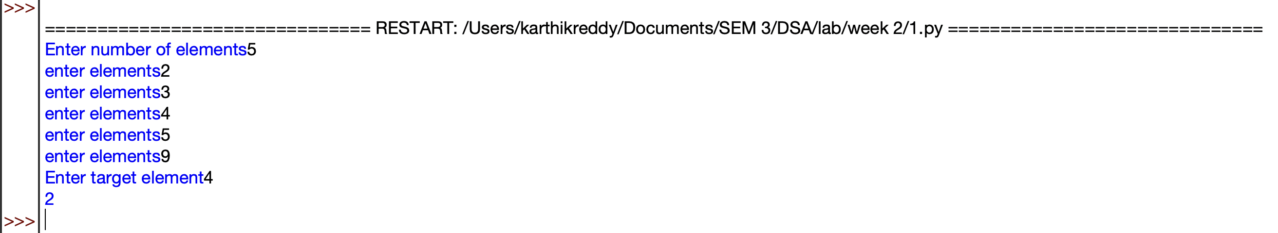
OUTPUT:

EXPLANATION:

- Takes the number of elements and stores them in a list.
- Takes the target element to be searched.
- linearSearch() checks each element one by one.
- If the target is found, its index is returned.
- If not found, -1 is returned.
- The result is displayed using print().

ERROR TABLE:
S.No. | Error Obtained | Rectification
1 | Element is not found | Check whether the required element is present in the list
2 | Wrong index is displayed | Check the list indexing starting from 0
3 | Search stops unexpectedly | Verify the range used in the for loop

2. AIM:

Write a Python program to perform binary search on the given input. Verify by taking sorted array & unsorted array as input.

PROGRAM:

def binary_search(a, low, high, key):
while low <= high:
mid = (low + high) // 2

if a[mid] == key:
return mid
elif a[mid] > key:
high = mid - 1
else:
low = mid + 1

return -1

n = int(input("Enter number of elements: "))
if n <= 0:
print("Number of elements must be positive.")
a = []
for i in range(n):
x = int(input("Enter element: "))
a.append(x)
a.sort()
print("Sorted list:",a)
key = int(input("Enter target element: "))
result = binary_search(a, 0, len(a) - 1, key)
if result != -1:
print("Element found at index",result)
else:
print("Element not found.")

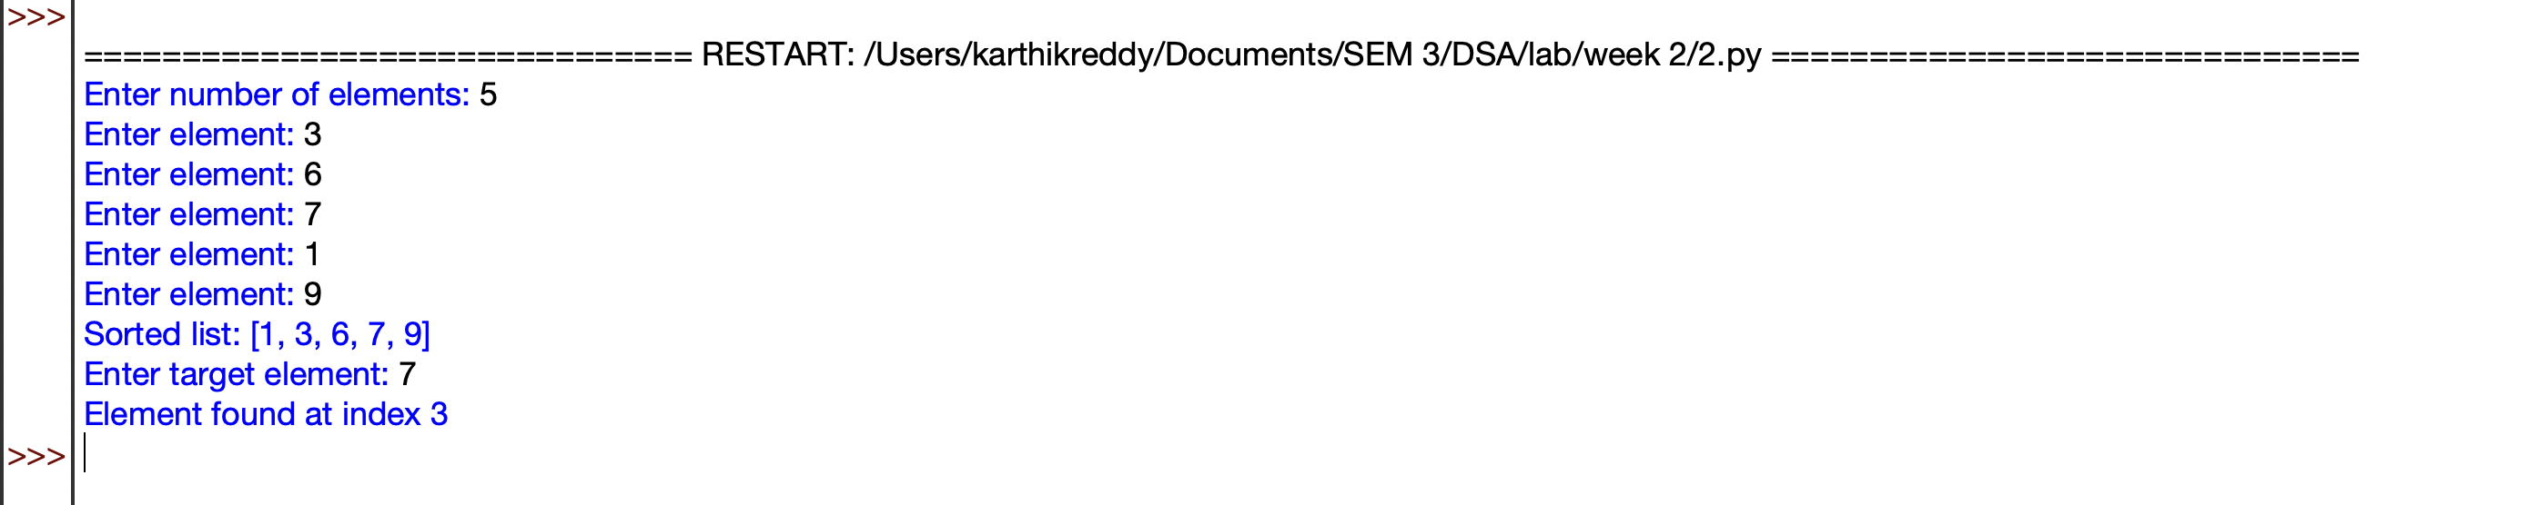
OUTPUT:

EXPLANATION:

- Takes the number of elements and stores them in a list.
- Sorts the list using a.sort() because binary search requires sorted data.
- Calculates the middle element and compares it with the target.
- If the target is smaller or larger, searches only the appropriate half.
- Returns the index if found; otherwise returns -1.
- Displays whether the element is found or not.

ERROR TABLE:
S.No. | Error Obtained | Rectification
1 | Wrong element is returned | Make sure the list is sorted before searching
2 | Search gives incorrect index | Check the calculation of the middle index
3 | Element is not found | Verify the low and high boundaries

